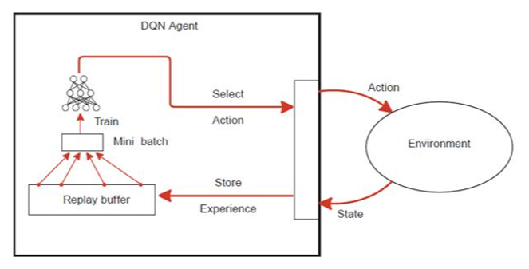

State: cpu usage

Action: # pods

and Reward

Pod

Pod

Pod

Kubernetes Cluster

